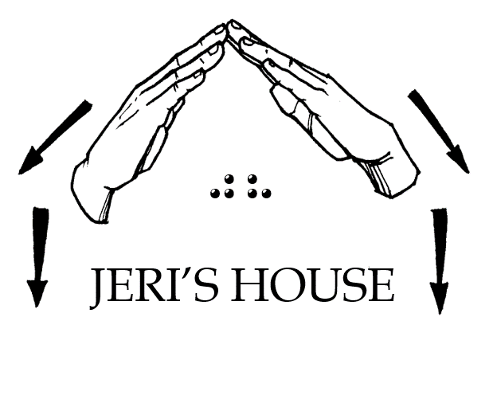
Jeri’s House, Inc.
P.O. Box 14192, Tulsa, OK 74159
Tel: (918) 200-6550 Web: www.jerishouse.org

RESIDENT’S GUIDELINES

OF JERI’S HOUSE

I. ELIGIBILITY
1. Individuals must meet the definition of DeafBlind as stated by the Helen Keller National Center, 1) the terms "Helen Keller National Center for Youths and Adults who are Deaf-Blind" and "Center" mean the Helen Keller National Center for Youths and Adults who are Deaf-Blind, and its affiliated network, operated pursuant to this chapter; (2) the term "individual who is deaf-blind" means any individual -(A)(i) who has a central visual acuity of 20/200 or less in the better eye with corrective lenses, or a field defect such that the peripheral diameter of visual field subtends an angular distance no greater than 20 degrees, or a progressive visual loss having a prognosis leading to one or both these conditions; (ii) who has a chronic hearing impairment so severe that most speech cannot be understood with optimum amplification, or a progressive hearing loss having a prognosis leading to this condition; and (iii) for whom the combination of impairments described in clauses (i) and (ii) cause extreme difficulty in attaining independence in daily life activities, achieving psychosocial adjustment, or obtaining a vocation; (B) who despite the inability to be measured accurately for hearing and vision loss due to cognitive or behavioral constraints, or both, can be determined through functional and performance assessment to have severe hearing and visual disabilities that cause extreme difficulty in attaining independence in daily life activities, achieving psychosocial adjustment, or obtaining vocational objectives; or (C) meets such other requirements as the Secretary may prescribe by regulation. This attestation must be signed by a physician or authorized personnel having a knowledge of such disability.
2. Individuals must be of minimum age of eighteen (18).
3. Individuals must pay one-half of their monthly income not to exceed $500 monthly to Jeri's House to cover expenses pertaining to their private rooms and meals. If individuals do not receive any monthly income, the individual must pay $250.00 per month. This monthly amount is subject to change according to current economics.
4. Individuals must desire to learn all aspects of independent living to transition to their own personal residence. Upon completion of personal goals set by the individual, assistance will be provided to help the individual relocate to their own residence with ongoing support. Ongoing support includes but not limited to advocacy, adjustment, and resources. Support does not include financial assistance.

II. PERSONAL ROOMS
1. Individuals must keep their private bedrooms clean at all times which includes but not limited to beds made, vacuumed and dusted, trash picked up and thrown away in the trashcans, clothes picked up off the floor, no food or drinks left out, and no piles of clutter,.
2. Individuals must keep the bathrooms cleaned which includes but not limited to cleaning sinks, toilets, showers, floor, and trash emptied.
3. Individuals may bring personal furnishings to replace items in their personal rooms with written permission from a staff of Jeri's House. Furnishing must be clean and not damaged.
4. Individuals must protect all of their own personal possessions such as jewelry, technology devices, money or any other personal items. Jeri's House is not responsible or liable for any lost or stolen personal items.

III. HOUSE RULES
1. Individuals must not partake of tobacco and must not be influenced with intoxicants on premises.
2. Individuals are not allowed to enter or visit each other in resident's private bedrooms.
3. Individuals must respect quiet time which is from 10 pm to 7 am.
4. Individuals must maintain their own personal laundry.
5. Individuals must maintain personal hygiene.
6. Individuals must clean up after themselves in all areas of the house.
7. Individuals must participate in all house activities unless otherwise excused by a staff member of Jeri's House.
8. Individuals must participate in household duties which include but not limited to kitchen details, preparing meals, lawn care, upkeep of living room and classroom areas. Duties will be rotated by-monthly.
9. Individuals must participate in classes for learning Braille, sign, craft, and Bible study.

