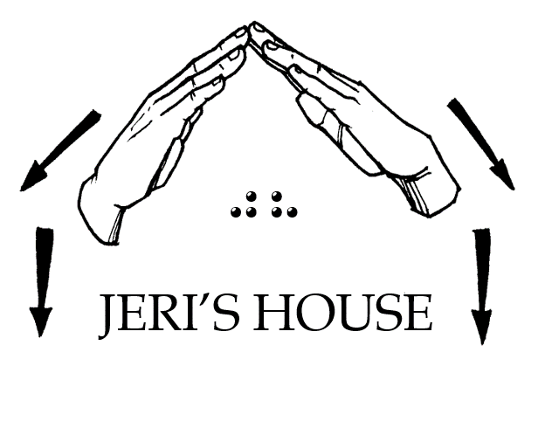
Jeri’s House, Inc.
P.O. Box 14192, Tulsa, OK 74159
Tel: (918) 200-6550 Web: www.jerishouse.org

APPLICATION FOR RESIDENTS

OF JERIS HOUSE

Jeri's House is a Bible Based 501©3 nonprofit Ministry. It has been organized to provide a safe place for individuals who are DeafBlind to transition to independent living, to promote and encourage self-esteem and self-confidence by creating a social, economic, and cultural transformation toward long-term sustainability.

ELIGIBILITY

Individuals must meet the Helen Keller definition of DeafBlind; must be 18 years or older; must be able to maintain one's own health; and must have a desire to transition to independent living.
Each individual will pay one-half of their monthly income not to exceed $500 monthly per person toward household expenses.
Individuals must abide by the rules set in the Residents Guidelines while living at Jeri's House.

PERSONAL INFORMATION

FULL Name:

STREET ADDRESS:

PHONE NUMBER:

EMAIL ADDRESS:

DATE OF BIRTH:

SOCIAL SECURITY NUMBER:

PLEASE INDICATE WHICH STATEMENT BEST IDENTIFIES YOU
Low vision and hard of hearing
Low vision and Deaf
Fully blind and hard of hearing
Bully DeafBlind

MODE OF COMMUNICATIONN: (please check more than one if applies)
Spoken English
Sign Language
Large print
Braille

PREFERRED FORMAT FOR CORRESPONDENCE:
Hard copy in large print
Hard copy in Braille
Email
Text

DO YOU HAVE ANY OTHER DISABILITY? IF SO, EXPLAIN:

CAN YOU SELF-MEDICATE?

SOURCE OF INCOME:

AMOUNT OF MONTHY INCOME:

EMERGENCY CONTACT INFORMATION

FULL NAME:

PHONE NUMBER:

RELATIONSHIP:

ATTESTATION

This form MUST be completed by an authorized personnel knowledgeable about the definition of DeafBlind. These may include but not limited to physician, optometrist, ophthamologist, Audiologist, Rehab Teacher, O&M Specialist, DeafBlind Counselor/Specialist, OR HKNC Representative.

1) the terms "Helen Keller National Center for Youths and Adults who are Deaf-Blind" and "Center" mean the Helen Keller National Center for Youths and Adults who are Deaf-Blind, and its affiliated network, operated pursuant to this chapter; (2) the term "individual who is deaf-blind" means any individual - (A)(i) who has a central visual acuity of 20/200 or less in the better eye with corrective lenses, or a field defect such that the peripheral diameter of visual field subtends an angular distance no greater than 20 degrees, or a progressive visual loss having a prognosis leading to one or both these conditions; (ii) who has a chronic hearing impairment so severe that most speech cannot be understood with optimum amplification, or a progressive hearing loss having a prognosis leading to this condition; and (iii) for whom the combination of impairments described in clauses (i) and (ii) cause extreme difficulty in attaining independence in daily life activities, achieving psychosocial adjustment, or obtaining a vocation; (B) who despite the inability to be measured accurately for hearing and vision loss due to cognitive or behavioral constraints, or both, can be determined through functional and performance assessment to have severe hearing and visual disabilities that cause extreme difficulty in attaining independence in daily life activities, achieving psychosocial adjustment, or obtaining vocational objectives; or (C) meets such other requirements as the Secretary may prescribe by regulation.

Resident’s Name:

Attestor’s Name:

Address:

Phone:

Email:

