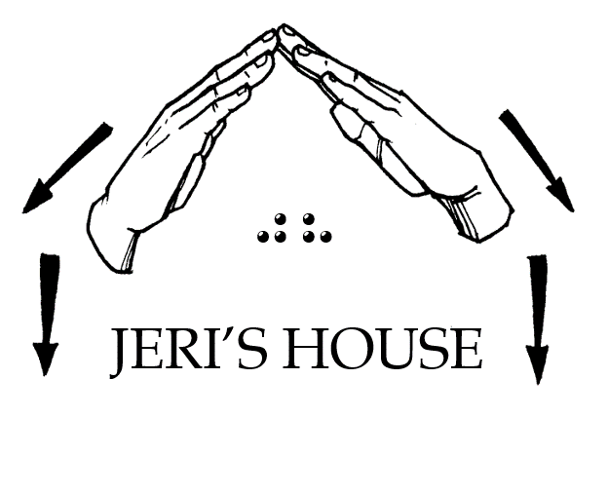
Jeri’s House, Inc.
P.O. Box 580695, Tulsa, OK 74158
Tel: (918) 200-6550 Web: www.jerishouse.org

APPLICATION FOR RESIDENTS

OF JERIS HOUSE

Jeri's House is a Bible Based 501©3 nonprofit Ministry. It has been organized to provide a safe place for individuals who are DeafBlind to transition to independent living, to promote and encourage self-esteem and self-confidence by creating a social, economic, and cultural transformation toward long-term sustainability.

ELIGIBILITY

- Individuals must meet the Helen Keller definition of DeafBlind;
- Must be 18 years or older;
- Must be able to administer one's own insulin or any other special medical needs outside the realm of general medical needs;
- Must have a desire to transition to independent living.

REQUIREMENTS

- Individuals will pay one-half of their monthly income not to exceed $500 monthly per person toward household and training expenses;
- Individuals must abide by the rules set in the Residents Guidelines while living at Jeri's House.

PERSONAL INFORMATION

FULL NAME:

STREET ADDRESS:

PHONE NUMBER:

EMAIL ADDRESS:

DATE OF BIRTH:

SOCIAL SECURITY NUMBER:

PLEASE INDICATE WHICH STATEMENT BEST IDENTIFIES YOU:
_____ Low vision and hard of hearing
_____ Low vision and Deaf
_____ Fully blind and hard of hearing
_____ Fully DeafBlind

PREFERRED MODE OF COMMUNICATION: (check all that apply)
_____ Spoken English
_____ Sign Language
_____ Large print
_____ Braille

IF SIGN LANGUAGE IS YOUR PREFERRED MODE OF COMMUNICATION PLEASE CHECK ALL THAT APPLY:
_____ ASL
_____ SEE
_____ PSE
_____ POP
_____ Finger Spelling
_____ Other

PREFERRED FORMAT FOR CORRESPONDENCE:
_____ Hard copy in large print
_____ Uncontracted Braille
_____ Contracted Braille
_____ Email
_____ Text message

DO YOU HAVE ANY OTHER DISABILITY? IF SO, EXPLAIN:

CAN YOU SELF-MEDICATE?

SOURCE OF INCOME:

AMOUNT OF MONTHY INCOME:

EMERGENCY CONTACT INFORMATION

FULL NAME:

PHONE NUMBER:

RELATIONSHIP:

ATTESTATION

This form MUST be completed by an authorized personnel knowledgeable about the definition of DeafBlind according to Helen Keller National Center. These may include but not limited to physician, optometrist, ophthalmologist, audiologist, Rehabilitation Teacher, O&M Specialist, DeafBlind counselor/specialist, or HKNC Representative.

1) the terms "Helen Keller National Center for Youths and Adults who are Deaf-Blind" and "Center" mean the Helen Keller National Center for Youths and Adults who are Deaf-Blind, and its affiliated network, operated pursuant to this chapter;
2) the term "individual who is deaf-blind" means any individual - (A)(i) who has a central visual acuity of 20/200 or less in the better eye with corrective lenses, or a field defect such that the peripheral diameter of visual field subtends an angular distance no greater than 20 degrees, or a progressive visual loss having a prognosis leading to one or both these conditions; (ii) who has a chronic hearing impairment so severe that most speech cannot be understood with optimum amplification, or a progressive hearing loss having a prognosis leading to this condition; and (iii) for whom the combination of impairments described in clauses (i) and (ii) cause extreme difficulty in attaining independence in daily life activities, achieving psychosocial adjustment, or obtaining a vocation; (B) who despite the inability to be measured accurately for hearing and vision loss due to cognitive or behavioral constraints, or both, can be determined through functional and performance assessment to have severe hearing and visual disabilities that cause extreme difficulty in attaining independence in daily life activities, achieving psychosocial adjustment, or obtaining vocational objectives; or (C) meets such other requirements as the Secretary may prescribe by regulation.

Resident’s Name:

Attestor’s Name:

Attestor’s Address:

Attestor’s Phone:

Attestor’s Email:

